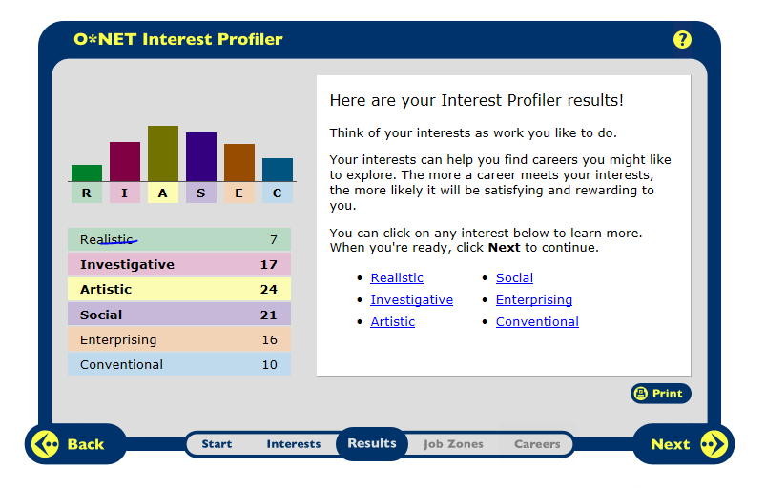

I agree with the top three results for my survey. They were artistic, social, and investigative. I am very artistic. I enjoy singing and playing instruments, as well as drawing pictures and being creative. The results showed my second highest career choice is a social job. I agree with this result because I am a very social person and I love talking and being with people. I am always with people because I do not like to be alone. My third highest result was an investigative career. I agree with this too. When I was younger I loved to play ‘detective’ and games along those lines. I love math and science. They are my favorite subjects.
~~~~~~~~~~~~~~~~~~~~~~~~~~~~~~~~~~~~~~~~~~~~~~~~~~~~~~~~~~~~~~~~~~~~~~~~~~~~~~~~~~~~~
Jobs:
Child Care Worker
Nursing
Drama or Music Teacher
Director
Model
Fashion Designer
Chiropractor
Mathematician

Career Research Data for 8 Career Occupations
Career Research Data for 8 Career Occupations | Child Care Worker | Nursing | Drama/Music Teacher | Director
HR1. Occupation Definition | care for children when parents and other family members are unavailable | An RN who has additional education and training in a specialty | instruct in a variety of subjects that students take for fun or self-improvement | creating motion pictures, television shows, live theater, and other performing arts productions
HR2. Related Occupations | Elementary School Teachers | RN , Physician Assistant | Artists, Choreographers | Actors, Announcers
HR3. Compatible Personality Types | Social | Social | Social | Artistic
HR4.Education/Training/Qualifications required | less than a high school diploma | A Master’s Degree | High school diploma or equivalent | Bachelor’s degree
HR5. Technology Skills needed | computers | Computers, infusion delivery systems and ventilators, Electronic Health Records | Smart Music, Tuners, Computers | creating motion pictures, television shows, live theater, and other performing arts productions
RC1. Entry Level Average Salary | $9.28 | Between $66,530 and $91,425 | $36,340 | $68,440
RC2. 10 yr. Projected Job Growth | 20% | 7% | 21% | 11%
RC3. Organizations that hire for this occupation | Childcare centers, their own home, or the homes of the children in their care. | hospital, Home-care, or a Nursing Home | Schools, Self-employed | motion picture and video industry
ISC1. Working Conditions | . Part-time work and irregular hours | Full- time hours | Regular Hours | assignments are usually short, ranging (1 day-a few months)
ISC2. Part of a Union? (Y/N) | no | Yes | Yes | no
ISC3. What kind of Advancement  Opportunities are there? | Raised salary | . Promotions or a raised salary | Larger Salary, Promotions | Another job, Increasing/different salaries
Universities/Colleges/Specialized  Training Organizations | BCC , Boston University | UMass Dartmouth, Curry | Emerson College | Pepperdine University, The University of the Arts
Career Research Data for 8 Career Occupations
Career Research Data for 8 Career Occupations | Model | Fashion Designer | Chiropractor | Mathematician
HR1. Occupation Definition | pose for artists, photographers, or customers to help advertise a variety of products | create original clothing, accessories, and footwear | treat patients with health problems of the musculoskeletal system | high-level mathematics and technology to develop new mathematical principles
HR2. Related Occupations | Acting, fashion designer | Modeling, graphic designer | Athletic Trainers, Massage Therapists | Computer Programmers, Financial Analysts
HR3. Compatible Personality Types | Artistic | Artistic | Investigative | Investigative
HR4.Education/Training/Qualifications required | Less than a high school degree | High School Diploma | Doctoral or professional degree | Master’s Degree
HR5. Technology Skills needed | Cameras | CAD Technology | Computer, Medical Devices | Calculator, Computer, Spreadsheets
RC1. Entry Level Average Salary | $32,920 | $64,530 | $67,200 | $99,380
RC2. 10 yr. Projected Job Growth | 14% | 0% | 28% | 16%
RC3. Organizations that hire for this occupation | comfortable studios and runway fashion shows | wholesale or manufacturing establishments | number are self-employed | work in the federal government and in private science and engineering research
ISC1. Working Conditions | part time and schedules can be unpredictable | 75% of all salaried fashion designers worked in NY and CA | work in a solo or group chiropractic practice | Full Time Job
ISC2. Part of a Union? (Y/N) | no | No | No | no
ISC3. What kind of Advancement  Opportunities are there? | Periods of unemployment | Competition for jobs | Promotions and Salary raises | Working higher up in the government
Universities/Colleges/Specialized  Training Organizations | You do not need a college degree for modeling | Columbus College of Art and Design, Baylor University | Palmer College of Chiropractic, UMass Amherst | University of New England, Rhode Island College

